Path of Moon in Newtonian Gravitation

Vivswan Shah

Department of Physics, Illinois College, 1101 W. College Ave. Jacksonville, Illinois 62650

Shah.Vivswan@ic.edu

**Abstract**

To determine the path of the moon with respect to the sun. The path of the moon with respect to the earth is elliptical and path of the earth with respect to the sun is elliptical. For this the simulation is created which use the Newtonian Universal Laws of Gravitation and traces the path of the moon. The final path of the moon is shown in graph 9. In graph 14, the clear nature of the moon path is seen.

**1. Introduction**

When an object is thrown upwards, it always comes down. While the moon does not fall to the earth, it orbits around the earth and the earth orbits around the sun. This led to observation that there is a force acting toward the earth which attracts the moon and make the moon moves around the earth. This force is called force of gravitation.

The concept of gravity was discovered very recently around 300 years ago. [1] The formulation of gravity was given by Sir Isaac Newton, which is called Universal Law of Gravitation. The observation of the motion of the astronomical bodies is not consistent with the motion predicted by the Newton’s universal laws of gravitation. Later, Albert Einstein gave the general theory of relativity, which is more accurate in predicting the motion of the astronomical bodies.

This paper will deal with the motion of the Moon when only Earth and Sun are present in the Universe and Newtonian Gravitation is followed.

***1.1. Universal Law of Gravitation***

The Universal Laws of Gravitation given by Sir Isaac Newton. Newton's law of universal gravitation states there is an attractive force between any two masses particle in the universe, which is proportional to the product of their masses and inversely proportional to the distance between there center of masses.

(1)

F = Force between the two particles

G = Gravitational Constant

M1 = Mass of one particle

M2 = Mass of another particle

r = Distance between the center of masses of two particles

***1.2. Path followed by object under gravity***

Orbit of a body with respect to the other can be parabolic, elliptical or hyperbolic. The general equation of the orbit is given by:

(2) [2]

a = length of semi-major axis

e = eccentricity of the ellipse

ϴ = polar angle

r = radial coordinate

φ = phase angle

Let φ = 180˚, then

(3)

If e = 0: circular orbit

0 < e < 1: elliptical orbit

e = 1: parabolic orbit

e > 1: hyperbolic orbit

Earth’s orbits around Sun in an elliptical path, and Moon orbits around Earth in an elliptical path. [3] Since it is elliptical, 0 < e < 1 and the elliptical orbit of one body relative to other body is a special case of general equation of Ellipse:

(4)

x = x position

y = y position

c1 = shift in x coordinate axis

c2 = shift in y coordinate axis

b = length of semi-minor axis

The eccentricity of an ellipse is defined as:

(5)

c = the distance between focus and the center

Considering r, the minimum distance between vertex to its respective focus:

(6)

(7)

b in term of given r and e:

(8)

(9)

Let focus be (0,0) then

(10)

(11)

Using (3), (5), (7):

(12)

Using (4), (5), (7), (9), (10), (11):

(13)

(12) and (13) are the trajectory of the object which it follows.

Standard gravitational parameter, µ for a mass system:

(14) [4]

Orbital velocity of the object in an elliptical orbit is given by:

(15) [5]

Using (5), (11), (12):

(16)

**2. Input Data**

(Note: all the input data is calculated when the Earth is closest to the foci where Sun is present and great solar eclipse initially)

Let Moon’s mass be 1, minimum distance between Moon and Earth be 10 and gravitational constant to be 6.67.

Using unitary method:

(17)

(18)

(19)

Then Earth and Moon velocity are calculated with () equation.

(20)

The velocity of the sun is then calculated with the above equation, to follow the law of conservation of momentum. Since this universe is comprise of only three bodies: Sun, Earth, Moon. The total momentum of the universe should be 0. With the help of all the above equations, the values for their respective variables is calculated.

For Unity software

(21)

Sun, Earth and Moon are located on x-z plane on x axis.

***2.1. Simulation 1:***

For simulation 1, the Moon is initially moving perpendicular to the direction of Earth’s initial velocity and the line formed by joining center of Earth and Sun with respect to the Earth.

|  |  |  |
| --- | --- | --- |
|  | Real Data | Simulation Data |
| Gravitational Constant |  |  |
| Sun Mass | [6] |  |
| Sun Maximum Velocity |  |  |
| Earth Mass | [7] |  |
| Earth Maximum Velocity | [7] |  |
| Earth Orbit Eccentricity | [7] |  |
| Earth Minimum Distance from Sun | [7] |  |
| Moon Mass | [8] |  |
| Moon Maximum Velocity | [8] |  |
| Moon Orbit Eccentricity relative to Earth | [8] |  |
| Moon Minimum Distance from Earth | [8] |  |

Table 1: Data used in Simulation 1

***2.2. Simulation 2:***

For simulation 1, the Moon is initially moving along the direction of Earth’s initial velocity with respect to the Earth.

|  |  |  |
| --- | --- | --- |
|  | Real Data | Simulation Data |
| Gravitational Constant |  |  |
| Sun Mass | [6] |  |
| Sun Maximum Velocity |  |  |
| Earth Mass | [7] |  |
| Earth Maximum Velocity | [7] |  |
| Earth Orbit Eccentricity | [7] |  |
| Earth Minimum Distance from Sun | [7] |  |
| Moon Mass | [8] |  |
| Moon Maximum Velocity | [8] |  |
| Moon Orbit Eccentricity relative to Earth | [8] |  |
| Moon Minimum Distance from Earth | [8] |  |

Table 2: Data used in Simulation 2

***2.3. Simulation 3 (Non – Realistic):***

(Note: This Simulation is just for tutorial purposes.)

For Simulation 3, The Sun is fixed in its position, Earth is 100 m away from the Sun and the ratio of the orbital period between Earth orbital period to Moon orbital period equal to the ratio of circumference of orbit of Earth to Moon. The masses and velocities of the Sun, Earth and Moon are calculated according to it.

The initial velocity of Moon is in the direction of initial velocity of Earth.

|  |  |  |
| --- | --- | --- |
|  | Real Data | Simulation Data |
| Gravitational Constant |  |  |
| Sun Mass | [6] |  |
| Sun Maximum Velocity |  |  |
| Earth Mass | [7] |  |
| Earth Maximum Velocity | [7] |  |
| Earth Orbit Eccentricity | [7] |  |
| Earth Minimum Distance from Sun | [7] |  |
| Moon Mass | [8] |  |
| Moon Maximum Velocity | [8] |  |
| Moon Orbit Eccentricity relative to Earth | [8] |  |
| Moon Minimum Distance from Earth | [8] |  |

Table 3: Data used in Simulation 3

**3. Design**

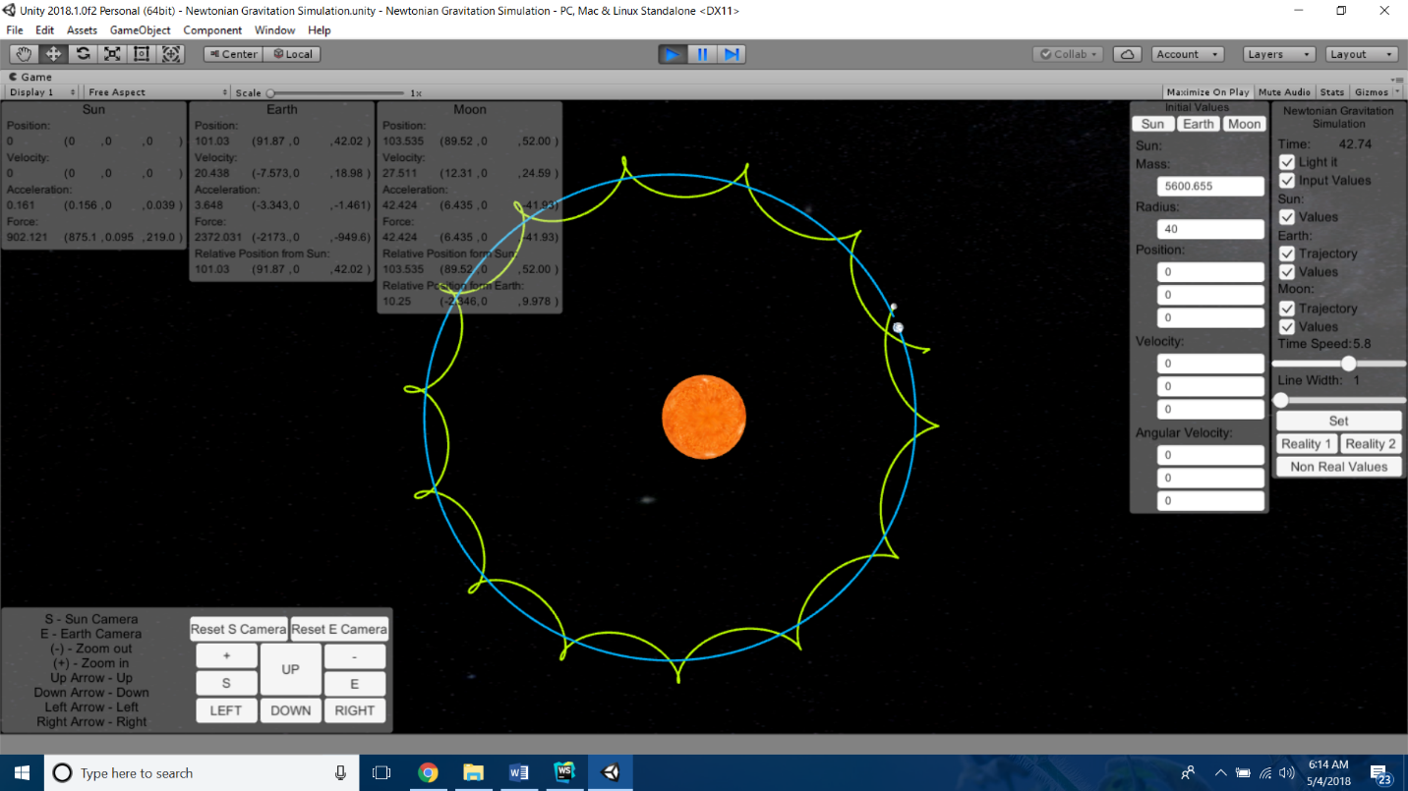 Image 1: Whole Screen

The simulation contains following items (shown in image 1):

1. Astronomical Bodies
   1. Sun
   2. Earth
   3. Moon
2. Cameras
   1. Overview: Orthogonal camera from far away.
   2. Earth: Preceptive camera close to the earth moving with the earth.
3. Scripts
   1. AstronomicalBody: It provides the interface in which all the astronomical bodies can attract each other with Newtonian gravitational force. It also instantiate Trajectory class and NewtonianGravitation class.
   2. Cameras: Toggle the two cameras.
   3. CanvasInputValues: Manages the input section of the canvas.
   4. CanvasUserValues: Manages each section of input section of the canvas.
   5. DataLog: Act as a logger for data collection.
   6. Functions: Stores all the static functions.
   7. MenuScript: Initialize the simulations and manages the menu section of the canvas.
   8. MoveableCamera: Makes the earth camera moveable and rotateable.
   9. NewtonianGravitation: Creates Newtonian force between the astronomical bodies.
   10. OverviewMoveableCamera: Makes the overview camera moveable.
   11. Pressed: Makes a new event which triggered on every update when the button is pressed.
   12. Trajectory: Traces the path of the astronomical object.
   13. VectorCanvas: Converts input values to vectors.

**4. Analysis**

***4.1. Simulation 1:***

Graph 1: Earth X position vs Z position Graph 2: Moon X position vs Z position

Graph 3: Earth X position vs Z position Graph 4: Earth X position vs Z position

Graph 5: Earth X position vs Z position Graph 6: Earth X position vs Z position

Graph 7: Earth X position vs Z position

***4.2. Simulation 2:***

Graph 8: Earth X position vs Z position Graph 9: Earth X position vs Z position

Graph 10: Earth X position vs Z position Graph 11: Earth X position vs Z position

Graph 12: Earth X position vs Z position

***4.3. Simulation 3 (Non – Realistic):***

Graph 13: Earth X position vs Z position Graph 14: Earth X position vs Z position

Graph 15: Earth X position vs Z position Graph 16: Earth X position vs Z position

Graph 17: Earth X position vs Z position

**5. Result**

From graph 1, 3, 5, 8, 10, 13, 15: it can be concluded the Earth moves in an elliptical orbit with very less inaccuracy around the Sun in all the simulations.

From graph 2, 4, 6, 9, 11, 14, 16: it can be concluded the Moon averagely follows elliptical orbit around Sun. Due to Earth’s gravitation moon also follows an elliptical path around the Earth which clear in graph 7, 12, 17 when other moon graphs are also consider in perspective .

In simulation 1, an interesting result is seen, the moon crashes into the Earth after approximately four and half year. So, this simulation fails.

In simulation 3, real life values are not used, due to that it can not be considered as a successfully simulation. Simulation 3 is only for tutorial purposes, it only shows how the moon move in a larger perspective.

In simulation 2, real life values are used, and the moon never crashes or goes out of it orbit, so this is a successful simulation.

**6. Conclusion**

A universe where Newtonian gravitation only exists, moon follow the path as shown in second simulation the moon will revolve around earth and earth will revolve around the sun. Resultant path is shown in Graph 9 but can be clearly seen in Graph 14. If Newton’s Universal Law of Gravitation is proven to be correct, then the simulation 2 is one of the ways, Moon will orbit around Earth and Sun.

**7. Acknowledgment**

Acknowledging the support of Dr. Prateesh Jakkala and Dr. Takako Soma from Illinois College for his guidance on this project. Also acknowledging following people for their respective unity packages.

1. Earth Rendering Free by Zheng Rong (<https://assetstore.unity.com/packages/vfx/shaders/earth-rendering-free-54914>)
2. MoonAndEarth by John van Vliet

(<https://github.com/keijiro/MoonAndEarth>)

1. Space Graphics Toolkit by Darkcoder

(<https://forum.unity.com/threads/space-graphics-toolkit-released.147954/>)

Finally, acknowledgement to Unity, the game engine with the help of which this project is completed.

**8. References**

1. Thompson, H., & Havern, S. (n.d.). Gravity. Retrieved May 4, 2018, from <https://web.stanford.edu/~buzzt/gravity.html>
2. Fowler, M. (n.d.). 15. Keplerian Orbits. Retrieved May 4, 2018, from <http://galileoandeinstein.physics.virginia.edu/7010/CM_15_Keplerian_Orbits.html>
3. Espenak, F. (n.d.). ECLIPSES AND THE MOON'S ORBIT. Retrieved May 4, 2018, from <https://eclipse.gsfc.nasa.gov/SEhelp/moonorbit.html>
4. Standard Gravitational Parameter. (n.d.). Retrieved May 4, 2018, from <http://www.vaporia.com/astro/start/standardgravitationalparameter.html>
5. Orbital Energy . (n.d.). Retrieved May 4, 2018, from <http://burro.case.edu/Academics/Astr221/Gravity/orbenergy.htm>
6. Williams, D. R. (2018, February 23). Sun Fact Sheet. Retrieved May 4, 2018, from <https://nssdc.gsfc.nasa.gov/planetary/factsheet/sunfact.html>
7. Williams, D. R. (2017, March 16). Earth Fact Sheet. Retrieved May 4, 2018, from <https://nssdc.gsfc.nasa.gov/planetary/factsheet/earthfact.html>
8. Williams, D. R. (2017, July 3). Moon Fact Sheet. Retrieved May 4, 2018, from <https://nssdc.gsfc.nasa.gov/planetary/factsheet/moonfact.html>